Laser cutting right from AutoCAD: A Guide for Engineers
The laser cutter is a very powerful and useful tool for engineering, design, architecture, and personal art projects. The laser cutters in the EXP Makerspace use vector files to cut or engrave your designs. Vector files (.ai, .svg, .dxf, .dwg, etc.) contain information about lines, curves, and fills, rather than a grid of pixels like a bitmap file (.png, .jpg, .psd, etc.) While bitmap files are great for photos or images, vector graphics are much preferred for all sorts of design and engineering work, and laser cutting is no exception.

Instead of using Adobe Illustrator to print your designs for laser cutting work, it can be very useful to print your designs directly from AutoCAD to the laser cutter. This saves the sometimes troublesome step of exporting your CAD design to Illustrator. This document serves as a guide to help patrons with exactly that; cut designs straight outta AutoCAD.

Unfortunately, to print from your own computer, you will need to have a windows computer, as the print driver for the laser cutter is only compatible with windows machines.

If you already have your design ready to go in its own AutoCAD file, follow these steps:

- First, use this link to download and follow the instructions to install the laser cutter print driver. You will need this if you want to cut right from your own computer.
- Have your design ready in AutoCAD. For this guide we’ll be using a gear as an example:
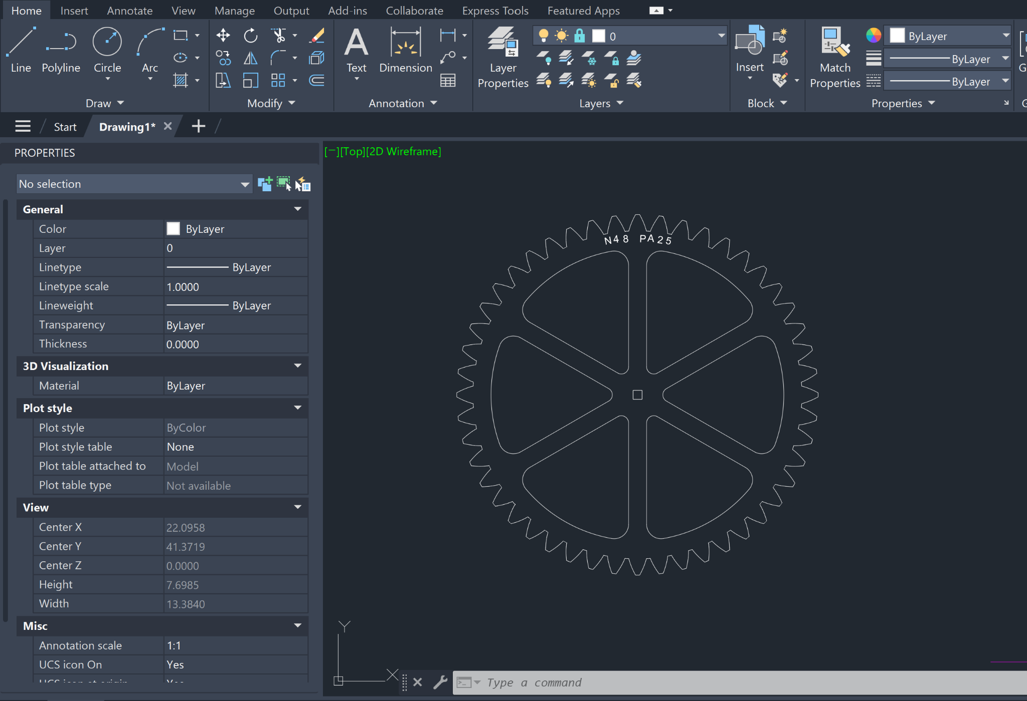

- Next, download and open the following AutoCAD template. You will need to be logged into a Northeastern email address to access it.

EXP PLS6.150D Laser cutting template.dwt

Link URL: https://northeastern.sharepoint.com/:u:/s/EXPMakerspacestaff/EaStp-0Z0PFHmri-DaR_k5cB9pIv-zTbH56soIppQUYHwQ?e=eBqakj

When you open it, it should look something like this:
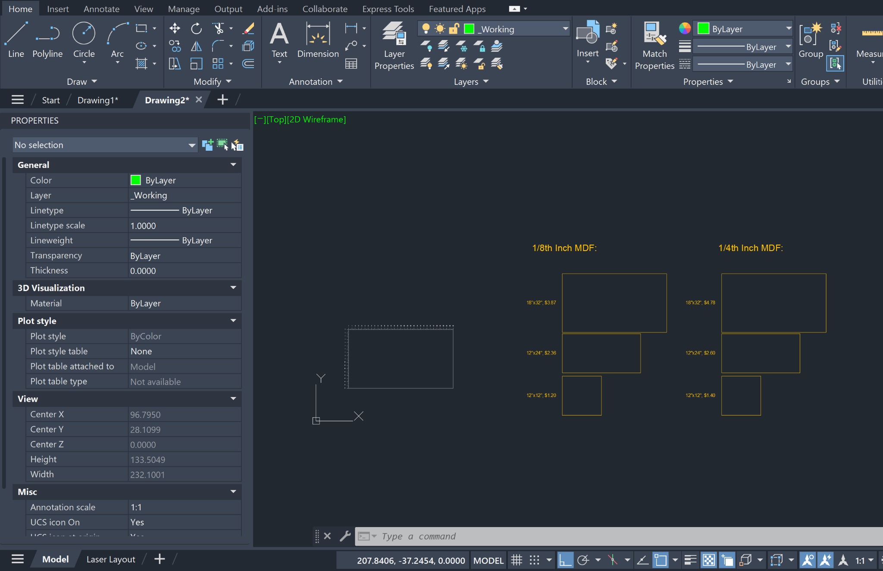

The template file has a lot of things going on at first, so let’s break it down.

- On the left, you will see a 18 inch by 32 inch outline of the laser bed for the small laser cutters. This is your available cutting area. You can see measurement markings on the top and left of the cutting area, which can help with alignment of your final cut. The lines and numbers of this are on their own layer which is locked and does not plot, so no need to worry about accidentally deleting or moving anything here.
- On the right you will see outlines for some common material sizes and costs. These can help you plan out how you might fit your design on a sheet of MDF or plywood for example. Please note that the prices may have changed.
- There are several layers in this file, but there are only 7 you need to worry about.
  - The first is a “_Working” layer and is bright green. This layer is for any scratch work or quick sketches you might want to do for your design. This is useful for banging out a quick prototype shape you might use later. This layer does not plot even if it is inside the cutting area.
  - Next, there are three layers for cutting, engraving, and raster. Just like you would set up a design in Adobe Illustrator, these layers have different colors for the different laser actions. The layers are identical except for their colors. Note that putting lines on the raster layer might not work out well, as this layer is intended for solid shapes, fills, or hatches.
  - Next, there are cutting, engraving, and raster hold layers. These layers are meant to serve as design “ghosts” for you to plan a cut around. These layers will not plot even if they are inside the cutting area. These are useful for if you want to add a cut onto a piece of material that you have already cut, but do not want to cut the same design twice. Simply move the designs you have already cut to a hold layer, and they will not be printed
- Lastly, on the bottom you will see a layout tab for the laser space. This page is a nice way you can get a final look at what your cut will look like. Note that layers that do not plot (e.g. cutting hold, _Working) will still display on this page.

- Next, simply copy and paste your design anywhere into the laser cutting template file:

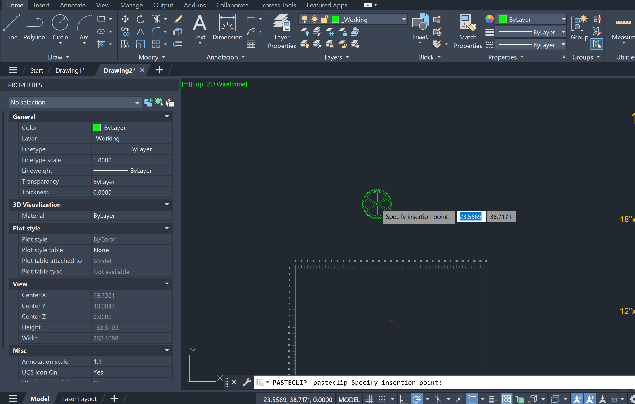
When you paste your design into the template file, it usually pastes into layer 0. This is fine, just know this layer will not plot even if inside the cutting area.

- Once your design is all copied over into the template file, simply move it inside the cutting area, and set your design elements to whichever laser action you’d like (cutting, engraving, etc.)
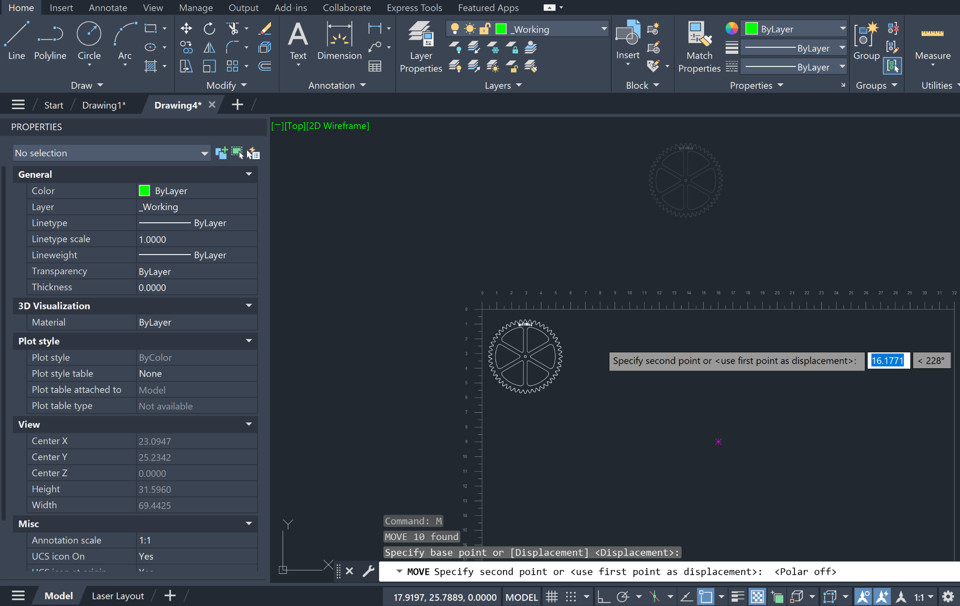

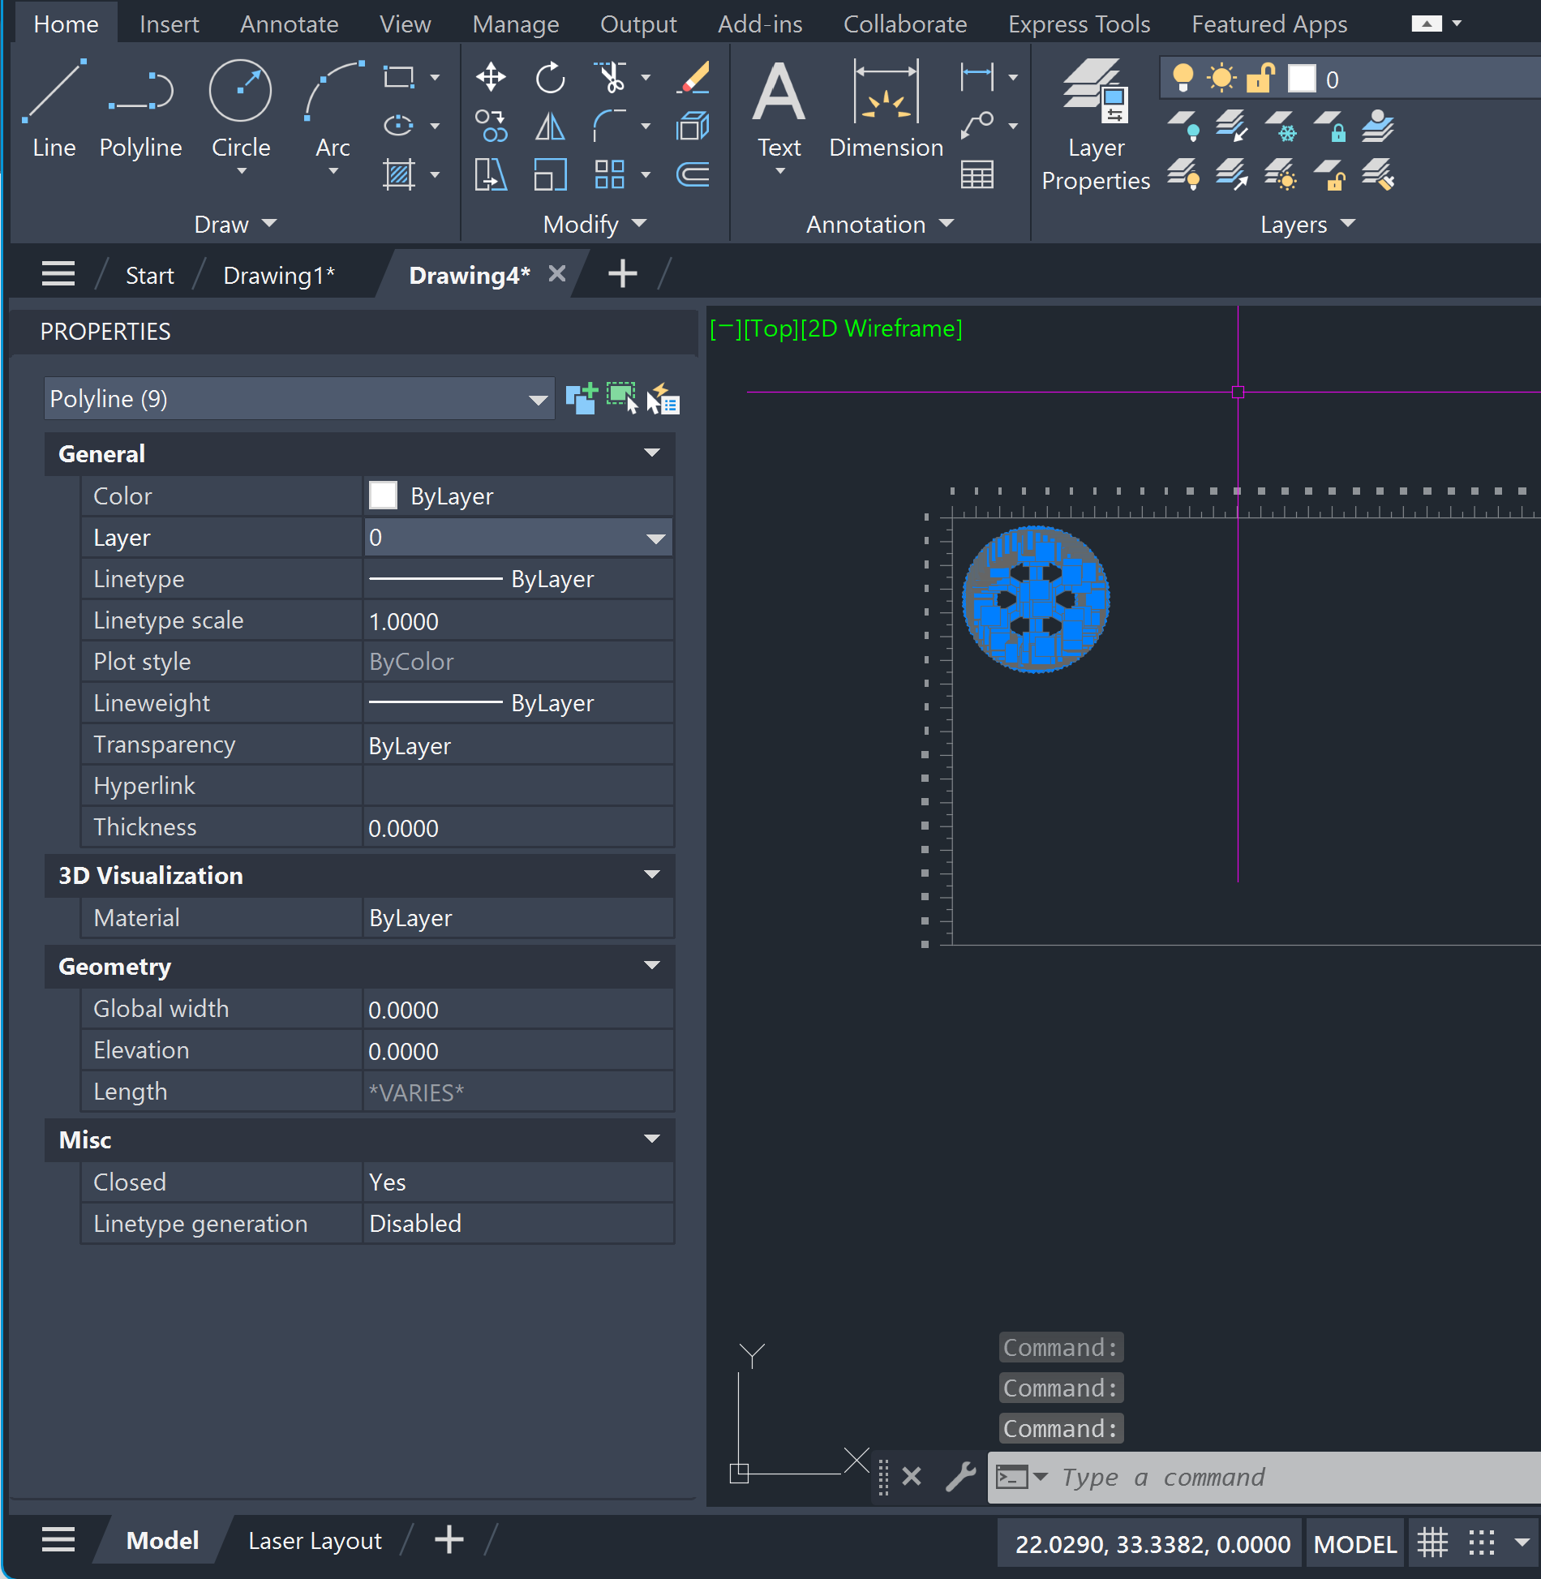

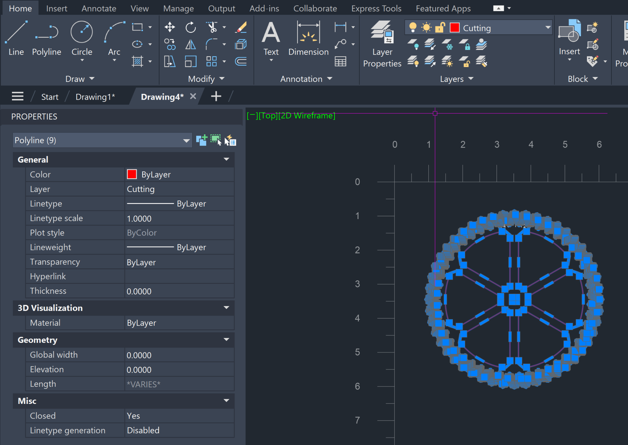

AutoCAD Tips:
- Press Ctrl/Cmnd + 1 to open the properties panel in AutoCAD. This lets you quickly change some properties of selected elements.
- Make sure the color of your design is selected to “By Layer.” This ensures everything is the correct color. You can do this by changing the “Color” option of a selected object.
- To change the layer of a selected object, click the dropdown next to the “Layer” option.

- Once you’re ready and everything is in its proper layer, go to the laser layout tab on the bottom. It should look like this:
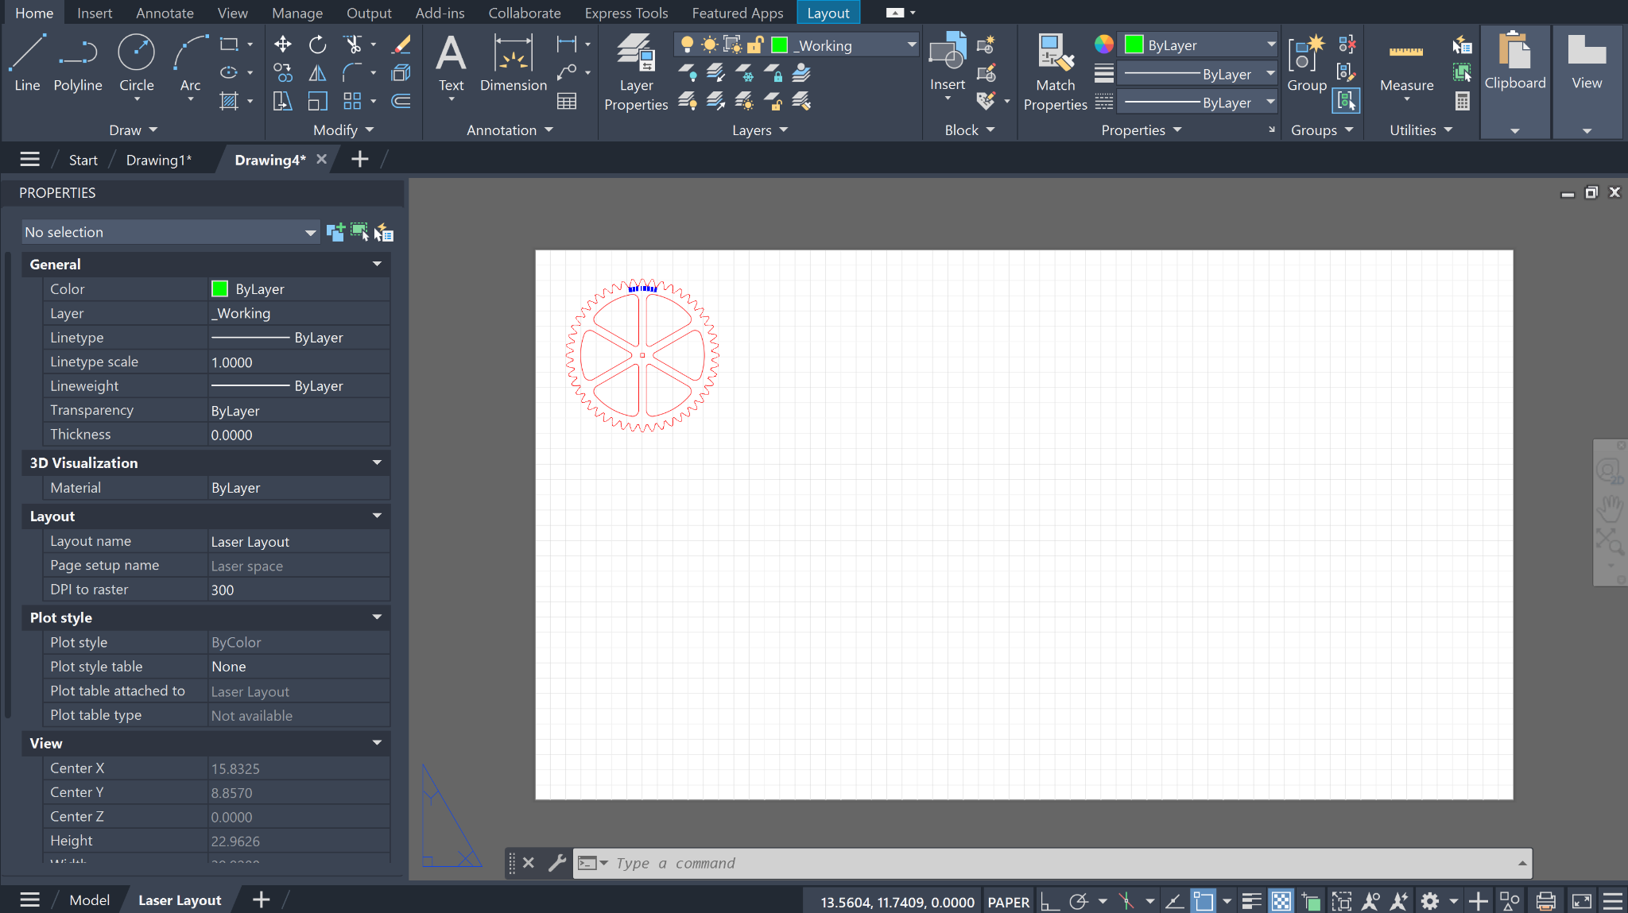

- Type “plot” into the command line and press enter.
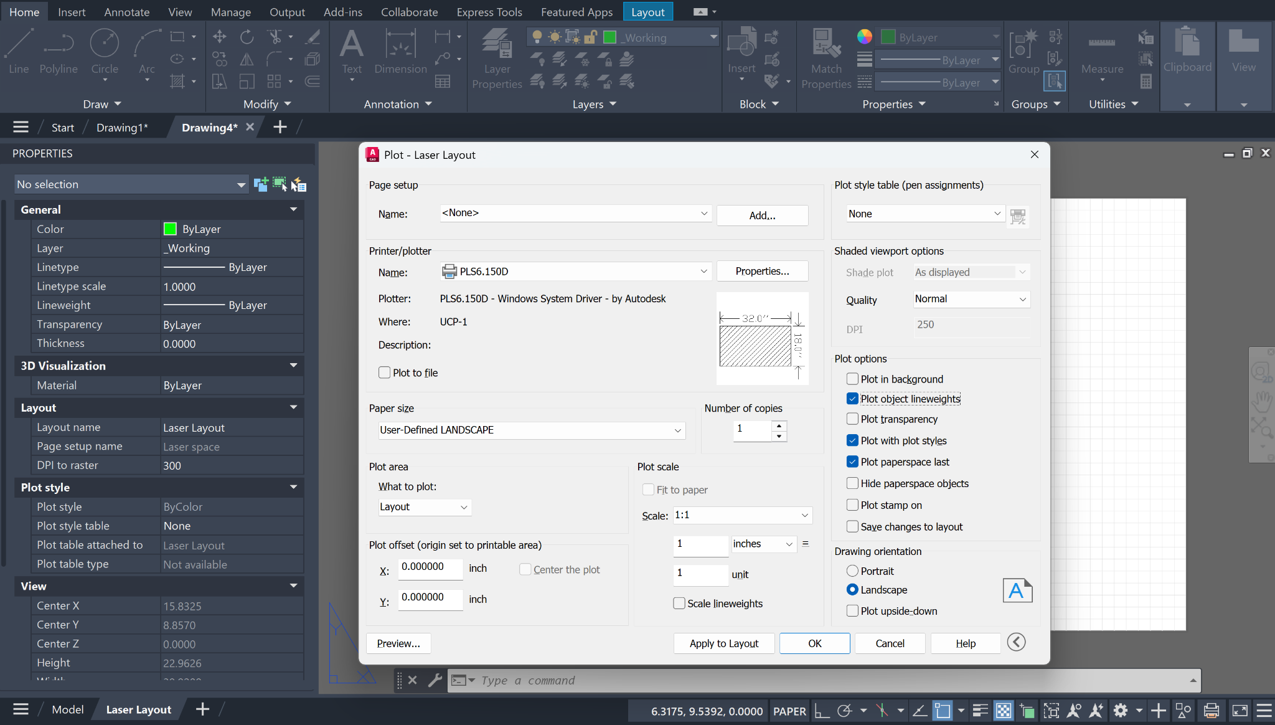
- Make sure the print driver “PLS6.150D” is selected under the “Printer/plotter” header. If you don’t see this option, it means you haven’t properly installed the UCP print driver. In the plot dialogue, uncheck “Plot object lineweights,” as this can mess with the output into UCP. Your plot settings should look like this in the end:
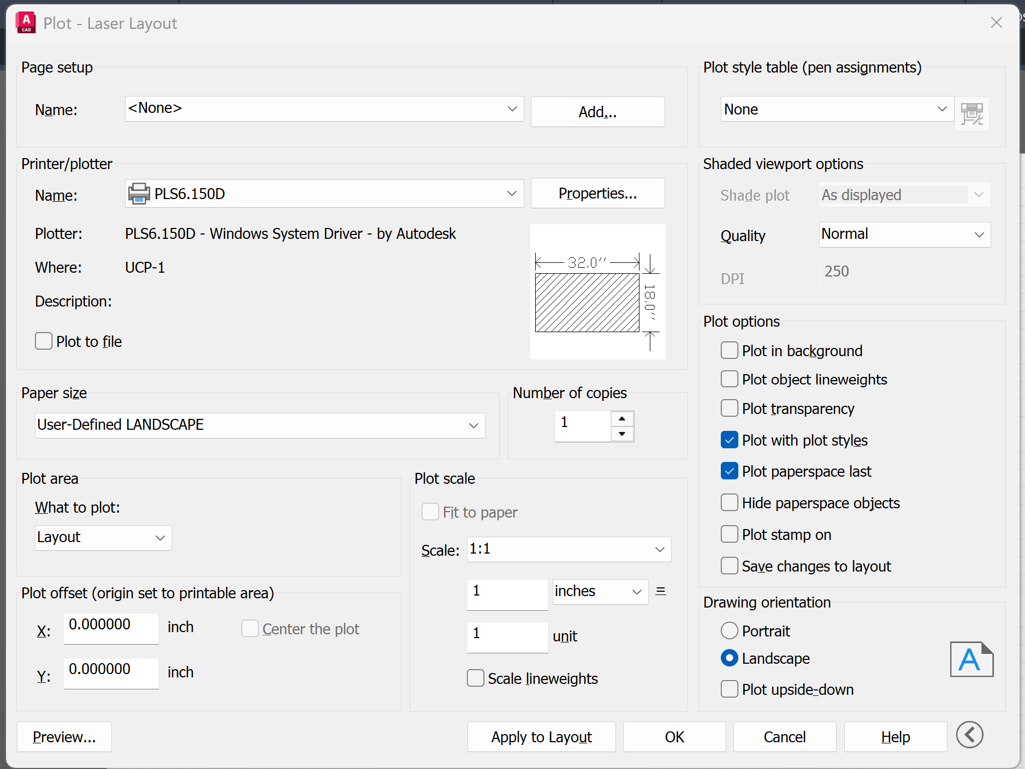
- Press “OK” and AutoCAD will print your design directly to UCP. Optionally, you can click “Preview” on the bottom left of the plot dialogue window to see what will be printed. This will show you what will be sent to the laser cutter. This can be helpful in making sure you haven’t put anything on the wrong layer and that everything is plotting correctly.
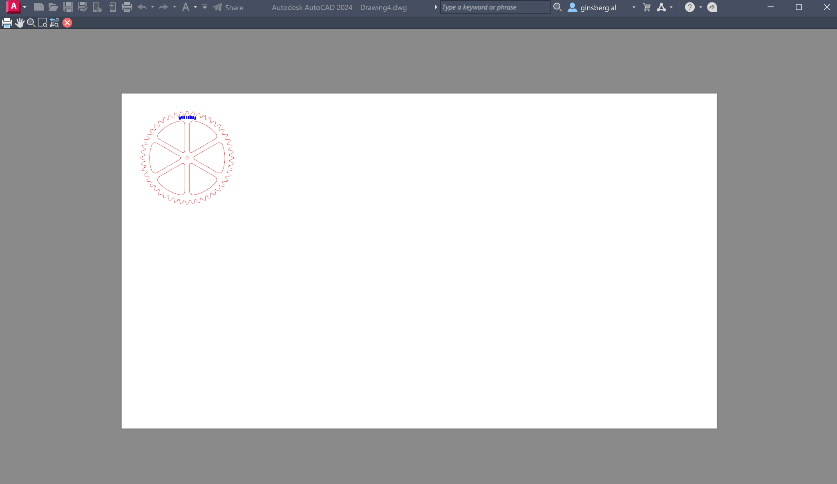

- Now you can simply open UCP in the same way you would after printing from Illustrator. Plug your computer into the laser cutter, wait for it to initialize, make sure your material settings are all correct and follow all laser safety measures, and you’re good to go! :)

